Diets main page

**HEALTHY DIET**

A healthy diet can protect the human body against certain types of diseases, in particular noncommunicable diseases such as obesity, diabetes, cardiovascular diseases, some types of cancer, and skeletal conditions. Healthy diets can also contribute to adequate body weight.

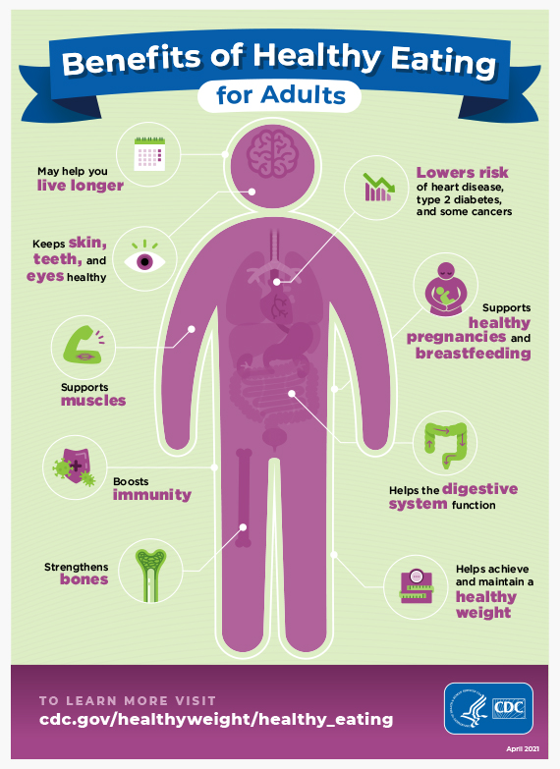

Benefits of Healthy Eating for Children

Picture of body identifying benefits of healthy eating for children.

* Keeps skin, teeth, and eyes healthy
* Supports muscles
* Helps achieve and maintain a healthy weight
* Strengthens bones
* Supports brain development
* Supports healthy growth
* Boosts immunity
* Helps the digestive system function

Benefits of Healthy Eating for Adults

Picture of body identifying benefits of healthy eating for adults.

* May help you live longer
* Keeps skin, teeth, and eyes healthy
* Supports muscles
* Boosts immunity
* Strengthens bones
* Lowers risk of heart disease, type 2 diabetes, and some cancers
* Supports healthy pregnancies and breastfeeding
* Helps the digestive system function
* Helps achieve and maintain a healthy weight

**How much protein should one consume in a day?**

When it comes to protein, non-vegetarians have loads of options such as meat, eggs, fish, and dairy products. But it is also important for one to know the right quantity of protein that should typically be consumed in a day*.*DieticianPrema Kodical says that on average one should consume 1.0g protein per kg of your body weight. For someone who is into weight training, the protein consumption varies according to the workout intensity. It can vary from 1.5g to 2.5g lean body mass.

Affect of food on us

A healthy diet can benefit your physical, mental, and social well-being in powerful ways. While the specifics vary, such a diet tends to emphasize nutritious whole foods, such as fruits, vegetables, whole grains, nuts and fish. It also provides sufficient amounts of calories, without going overboard, and ideally brings you enjoyment as well. Keep in mind that nutritional steps should never replace needed medical treatment. Especially if you have a health condition, talk to your doctor before making significant changes to your eating plan.